The Challenges of Building the Railway across Canada
Source: Goodman, D.M., J.C., & Smith, T.A. (2007). Voices of Canada: People, Places, and Possibilites. Toronto, ON, Pearson Education.
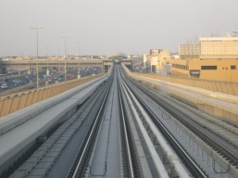
A railway across Canada started as a dream. John A. MacDonald wanted the new country to stretch from the Atlantic Ocean to the Pacific Ocean.

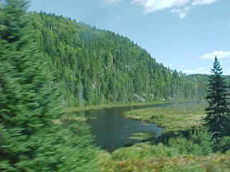
For his dream to come true, though, people would have to build 5000 kilometers of railway tracks across the muskeg of the Shield and through mountains. No one had ever built such a railway in Canada or anywhere else in the world. Many people thought it was an impossible dream. But once again, Canadians worked together to identify the challenges and discuss possible solutions.

Solving Challenges
The story of the railway was a story of great determination. People such as William Van Horne, Andrew Onderdonk, and Major A.B. Rogers wanted to make Sir John A. MacDonald’s dream come true.

William Van Horne was the chief engineer for the railway. Andrew Onderdonk was in charge of the British Columbia section of the railway.
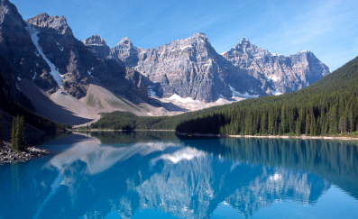
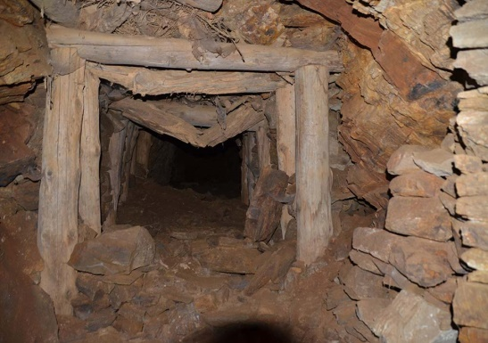
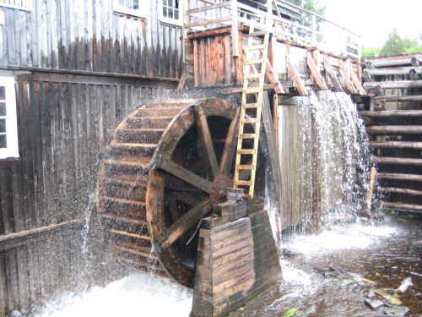
Major A.B. Rogers was a surveyor who would not quit until he found a way, or a pass, through the Rocky Mountains. Each of these men believed the impossible could be done. They imagined what the country of Canada might look like. They saw factories, mines, and mills, and more cities and towns.

