Before There Were Trains
text source: (excerpt from Library and Archives Canada: Canada by Train. https://www.collectionscanada.gc.ca/
trains/021006-1000-e.html)
Images source: http://www.dailymail.co.uk/news/article-2276509/Think-Nemo-bad-How-19th-century-Americans-dealt-snow-removal-help-salt-truck.html

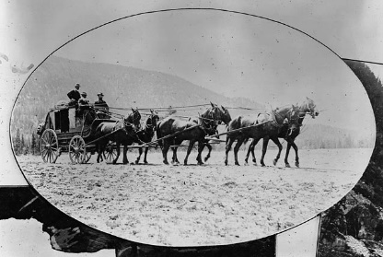
Before the first passenger train was created for use in what we now call Canada, it was very difficult for people to travel from one place to another. Diaries and journals tell stories about the long and dangerous trips people would take before railroads. They would have to walk, or use wagons and sleighs pulled by horses. Many people would have to use this way of travelling along with taking trips on large ships across oceans. Back in the early 19th century people did not have many roads they could use to travel.

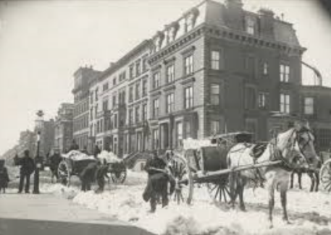
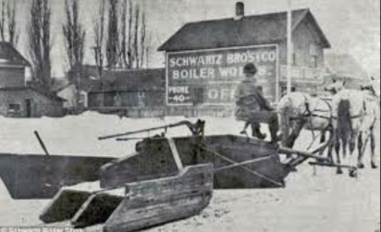
If a road existed, it was tough to travel because of all the mud produced by all the rain. Some places would use large logs on the roads and this made it very dangerous for people using wagons to travel. The wagon wheels would get stuck on these logs making it very difficult and dangerous for people to pass over.

Eventually, people made roads using broken stones and sticky tar. This made travel easier but cost a lot of money to keep them in good condition.
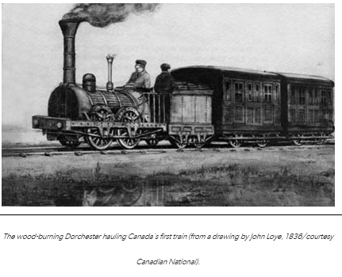
Before railroads, it took thirty-six hours to go between Montreal and Toronto. Most people could not visit places like Newfoundland or the Arctic because it was too dangerous and it took too long to get there.

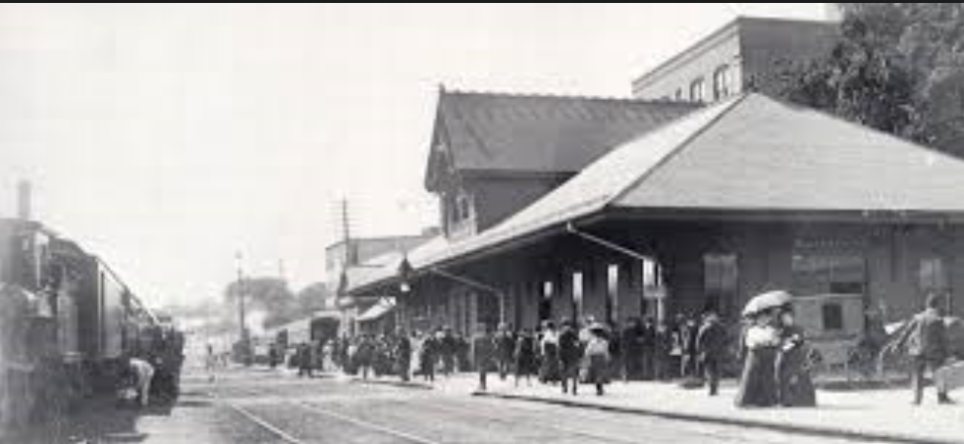
In 1836 people started feeling excited because the government started building railroads. People living in small towns could now visit people in other towns as well as get different items like food and clothes from other places. All these trains meant people could connect with each other and share food supplies and other needed items. People could travel from place to place easier and quicker than before.

Government leaders felt excited by the railroad and promised to make it so that everyone could be connected to each other. Sadly, it was too expensive to keep railways operating and many companies did not have enough money to keep them operating.

Government could not start making new railroads because they did not have any money. Many government officials did not realize how expensive it was to build railroads. People from different towns began to argue and fight over who would be the first to have a railroad in their town.

